# Sound splitter v.1.0 beta

## Description

“Sound splitter” is a free Windows application that splits large audio and video files (e.g. of public speeches, presentations), recorded in the most popular formats, such as wav, mp3, flv, mp4, wma, into smaller wav (or mp3) files of around 60 MB in size. It makes an attempt to cut the input file in a silent place, so that a word in a recorded speech is not split in the middle.

Supported **input file formats** include as a minimum the following formats:

* audio formats: wav, mp3, wma, ogg, aac, ...
* video formats: mp4, avi, flv, ...

You can try other input file formats supported by FFMPEG.

The **output files** are 16 kHz 16 bit wav or mp3 files, depending on the application you are using: sound_splitter.exe outputs files in **wav** format, sound_splitter_mp3.exe outputs files in **mp3** format.

The file splitting allows you a hassle-free upload of very large files to online services (e.g. Speech to text service).

## Usage

Always make a secure copy of the original file before doing any operations with Sound Splitter.

Using your mouse, drag and drop the audio or video file in question on the application sound_splitter.exe. The application should start processing the file immediately.

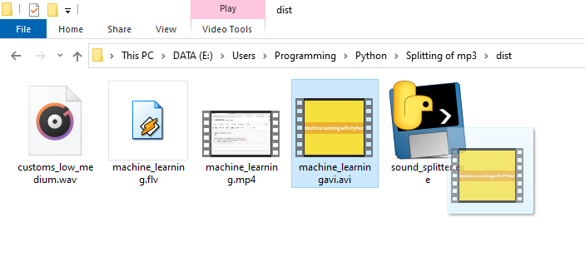

The file is split into the following parts: small files with the filename containing chunk_1, chunk_2, chunk_3… and a full-length 16 kHz 16 bit wav audio file containing the word “original” in its filename (in case you need a complete audio track of a video file, for example). 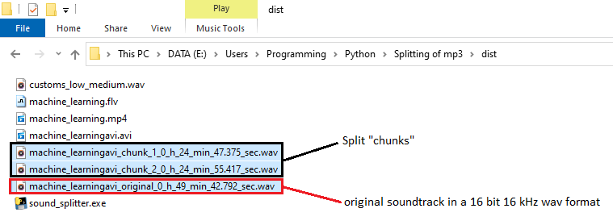

## Installation

A sole **Sound_splitter** dependency is the application FFMPEG.

It’s available at the official website [ffmpeg.org](http://www.ffmpeg.org).

Windows version is available at <https://ffmpeg.org/download.html#build-windows>.

Direct download link: <https://www.gyan.dev/ffmpeg/builds/ffmpeg-release-essentials.zip>.

As Sound splitter uses ffmpeg for file conversion, ffmpeg needs to be discoverable by Sound splitter. For that, ffmpeg bin directory must be included in the “path” environmental variable of Windows.

Follow the steps below, to include ffmpeg in PATH environmental variable under Windows 10:

